**TECHNOLOGY BASED BUSINESS TRANSFORMATION.**

**TOPIC-3 SUCCESS STORIES OF BRAND DIGITAL TRANSFORMATION.**



1. MCDONALD- MCDONALD IS AN AMERICAN MULTINATIONAL FOOD CHAIN, FOUNDED IN 1940 AS A RESTAURANT OPERATED BY RICHARD AND MAURICE MCDONALD, IN SAN BERNARDINO, CALIFORNIA, UNITED STATES. THEY GAVE A NEW NAME TO THEIR BUSINESS AS A HAMBURGER STAND AND LATER TURNED THE COMPANY INTO FRANCHISE. MCDONALD IS THE WORLD’S LARGEST FOOD RESTAURANT CHAIN, SERVING OVER 69 MILLION CUSTOMERTS DAILY IN OVER 100 COUNTRIES. IT IS BEST KNOWN FOR ITS BURGERS AND FRENCH FRIES. THE BRAND HAS EMBRACED DIGITAL TRANSFORMATION TO STAY AHEAD IN THE RAPIDLY EVOLVING LANDSCAPE. BY LEVERAGING INNOVATIVE TECHNOLOGIES, THE COMPANY IS ENHANCING CUSTOMER EXPERIENCES AND OPERATIONAL EFFICIENCY.

* CHALLENGES FACED BY MCDONALD’S:
* **SHIFTING CONSUMER PREFENCES-** CUSTOMERS DEMAND MORE PERSONALIZED, CONVIENT, AND TECHNOLOGICALLY ADVANCED DINING EXPERIENCES.
* **INTENSE COMPETITON**- COMPETITORS ARE ALSO INVESTING IN DIGITAL SOLUTIONS, CREATING A NEED FOR MCDONALD’S TO STAY COMPETITIVE.
* **CYBERSECURITY CONCERNS-** PROTECTING CUSTOMER DATA AND SAFEGUARDING DIGITAL SYSTEMS IS CRUCIAL IN THE AGE OF INCREASED CYBER THREATS.
* **TECHNOLOGIES USED**:

|  |  |  |  |
| --- | --- | --- | --- |
| AI-POWERED ORDERING | MOBILE PAYMENTS | LOYALTY AND REWARDS | ROBOTIC FOOD PREPARATION |
| THE APP ALLOWS CUSTOMERS TO CUSTOMIZE THEIR ORDERS,SAVE PREFENCES, AND REORDER FAVORITES WITH EASE. | CUSTOMERS CAN SECURELY PAY FOR THEIR MEALS DIRECTLY THROUGH THE APP, REDUCING WAIT TIMES. | THE APP’S INTEGRATED LOYALTY PROGRAM OFFERS EXCLUSIVE DISCOUNTS AND REWARDS, ENCOURAGING REPEAT BUSINESS. | THE COMPANY IS INVESTING IN ROBOTIC TECHNOLOGY TO AUTOMATE CERTAIN FOOD PREPARATION TASKS, IMPROVING EFFICIENCY AND CONSISTENCY. |
|  |  |  |  |

|  |  |
| --- | --- |
| BEFORE | AFTER |
| DRIVE-IN RESTAURANT | EXPANDED ACROSS ALL OVER AND BECAME GLOBAL SYMBOL OF FASTFOOD CULTURE. |
| SIMPLE MENU | MENU DIVERSIFICATION. |
| NOT MUCH INNOVATION | INNOVATIVE MARKETING STARTEGIES, GLOBAL SPONSORSHIPS, ETC. |
| TRADITIONAL WAY OF MARKETING. | IN RECENT YEARS, IT HAS ADVANCED THEIR TECHNOLOGIES LIKE MOBILE ORDERING, SELF-SERVICE, ETC. |
| LESS GROWTH. | FINANCIAL GROWTH. |

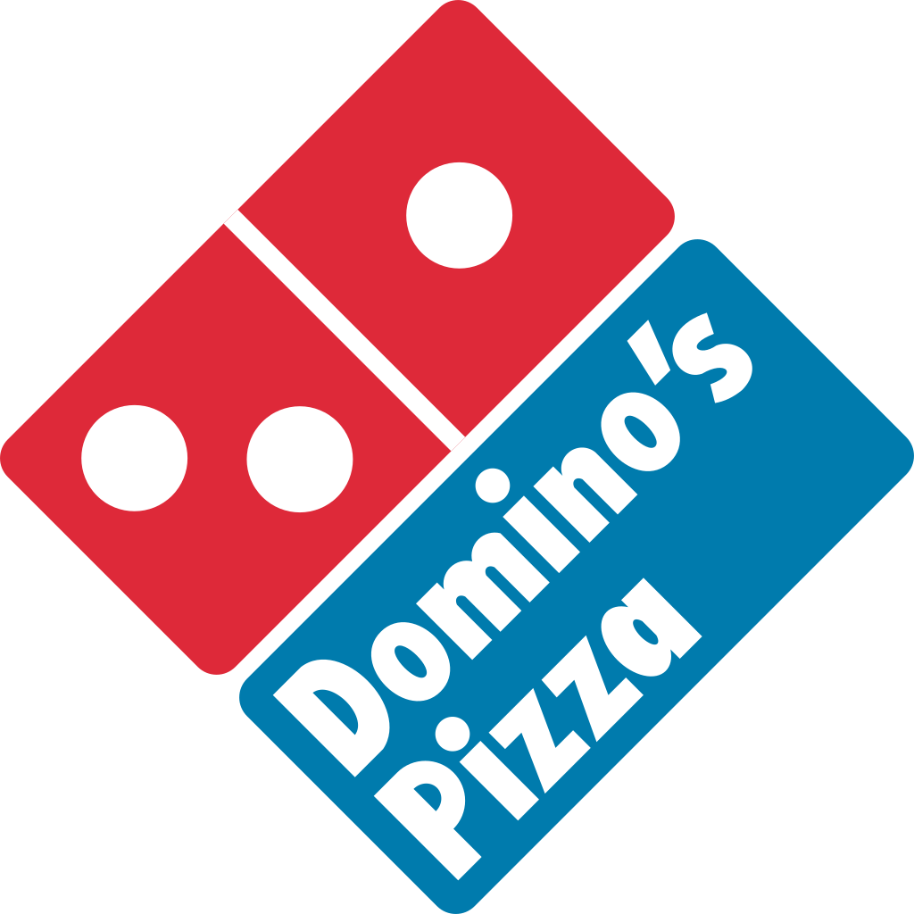

[This Photo](https://commons.wikimedia.org/wiki/File:Dominos_pizza_logo.svg) by Unknown Author is licensed under [CC BY-SA](https://creativecommons.org/licenses/by-sa/3.0/)

**2.DOMINO’S**- Domino’s came from humble beginnings in 1960, with just one store. Now, as the largest pizza company in the world, Domino’s proudly continues its legacy of delivering great-tasting pizza to customers’ doors.

**PURPOSE AND VALUES**- Domino’s believes in doing the right thing, putting people first, creating inspired solutions, championing our customers, and growing and winning together.

* CHALLENGES FACED BY DOMINO’S:

|  |  |  |  |  |
| --- | --- | --- | --- | --- |
| CYBER SECURITY THREATS | COMPETTION FROM DELIVERY SERVICES | MOBILE APP PERFORMANCE | USER ENGAGEMENT | DIGITAL MARKETING STRATEGY |
| WITH THE INCREASING RELIANCE ON DIGITAL PLATFORMS FOR ODERING AND PAYMENT, DOMINO’S MUST CONTINOUSLY SRENGTHEN ITS CYBERSECURITY MEASURES TO PROTECT SENSITIVE CUSTOMER DATA. | **THE RISE OF THIRD-PARTY DELIVERY PLATFORMS LIKE ZOMATO, SWIGGY, EAT CLUB, ETC PRESENTS INTENSE COMPETITION.**  **DOMINO’S NEEDS TO FIND WAY TO DIFFRENTIATE ITS SERVICES AND MAINAIN GOOD CUSTOMER LOYALTY IN A CROWEDED MARKET.** | **ENSURING A SEAMLESS, USER-FRIENDLY MOBILE APP EXPERIENCE IS CRUCIAL.TECHNICAL ISSUES, PROBLEMS, AND SLOW PERFORMANCE CAN LEAD TO CUSTOMER FRUSTATION AND LOST SALES.** | **MAINTANING HIGH LEVELS OF USER ENGAGEMENT ON DIGITAL PLATFORMS IS ESSENTIAL. THIS INVOVLES REGULAR UPDATES, PROMOTIONS, LOYALTY PROGRAMS, AND PERSONALIZED MARKETING EFFORTS, WHICH CAN BE CHALLENGING TO EXECUTE EFFECTIVELY.** | **KEEPING UP WITH THE LATEST TRENDS IN DIGITAL MARKETING WHILE EFFECTIVELY TARGETING THE RIGHT AUDIENCE THROUGH VARIOUS ONLINE CHANNELS CAN BE CHALLENGING DUE TO RAPID CHANGES IN TECHNOLOGY AND CONSUMER BEHAVIOR.** |

* BEFORE AND AFTER:

|  |  |
| --- | --- |
| BEFORE | AFTER |
| IN 1980s AND 1990s, COMPANY FACED CRITICISMS ABOUT QUALITY OF FOOD. | IN 2009, DOMINO’S LAUNCHED A MAJOR REBRANDING CAMPAIGN, FOCUSED ON IMPROVING ITS QUALITY. |
| MENU LIMITATIONS. | MENU EXPANSIONS. |
| NO TASTE AND FRESHNESS. | FRESH PIZZAS WITH TASTE AND BETTER QUALITY. |
| TRADITIONAL MARKETING METHODS. | MODERN MARKETING METHODS. |
| NO SOCIAL MEDIA ENGAGEMENT. | SOCIAL MEDIA ENGAGEMENT INCREASED. |

* **TECHNOLOGIES USED:**

|  |  |  |  |
| --- | --- | --- | --- |
| ONLINE ODERING PLATFORMS | DOMINO’S TRACKER | AI | VOICE ORDERING |
| DOMINO’S PROVIDES A USER-FRIENDLY WEBSITE AND MOBILE APP THAT ALLOW CUSTOMERS TO PLACE ORDER EASILY. THE PLATFORMS OFTEN INCLUDES FEATURES LIKE TRACKING, CUSTOMIZED ORDERS, AND PAYMENT OPTIONS. | THIS REAL-TIME TRACKING SYSTEM ALLOWS CUSTOMERS TO SEE THE STATUS OF THEIR ORDERS FROM PREOARATION TO DELIVERY. | AI IS USED IN VARIOUS CAPACITIES, SUCH AS CHATBOTS FOR CUSTOMER SERVICES, PREDICTIVE ANALYSIS FOR INVENTORY MANAGEMENT, OPTIMIZING DELIVERY ROUTES. | THROUGH PARTNERSHIPS WITH VOICE-ACTIVATED DEVICES LIKE AMAZON’S ALEXA AND GOOGLE HOME, CUSTOMERS CAN PLACE ORDER USING VOICE COMMANDS. |



1. **JIOMART-** JIOMART IS AN INDIAN E-COMMERCE PLATFORM, OWNED BY RELIANCE RETAIL. LAUNCHED IN DECEMBER 2019, IT INITIALLY FOCUSED ON ONLINE GROCERIES BEFORE EXPANDING INTO OTHER CATEGORIES SUCH AS FASHION, HOME ESSENTIALS, ELECTRONICS, AND LIFESTYLE PRODUCTS BY ADOPTING A MARKETPLACE MODEL. A PILOT WAS LAUNCHED IN SELECT AREAS OF NAVI MUMBAI, THANE AND KALYN IN APRIL 2020. IN MAY 2020, JIOMART WAS FULLY LAUNCHED IN 200 CITIES AND TOWNS ACROSS INDIA.

* **CHALLENGES FACED BY JIO MART**:

**INTENSE COMPETITION**- THE INDIAN E-COMMERCE AND ONLINE GROCERY MARKET IS HIGHLY COMPETITIVE, WITH ESTABLISHED PLAYERS LIKE BIGBASKET, AMAZON PANTRY, AND NEWER ENTRANTS. DIFFRENTIATING ITSELF AND MAINTANING MARKET SHARE CAN BE DIFFICULT.

**SUPPLY CHAIN MANAGEMENT**- EFFICIENTLY MANAGING A COMPLEX SUPPLY CHAIN, ESPECIALLY FOR PERISHABLE GOODS, IS CRUCIAL. DELAYS OR DISRUPTIONS CAN LEAD TO CUSTOMER DISSATISFACTION AND LOSS OF BUSINESS.

**TECHNOLOGICAL INFRASTRUCTURE-** ENSURING A ROBUST AND SCALABLE TECHNOLOGICAL PLATFORM IS CRUCIAL AS THEY MAINTAIN A LARGE USER BASE. DOWNTIME OR TECHNICAL GLITCHES IN THEIR APP OR WEBSITE CAN FRUSTATE CUSTOMERS AND LEAD TO LOST SALES.

* **TECHNOLOGIES USED BY JIO MART-**

|  |  |  |  |
| --- | --- | --- | --- |
| E-COMMERCE PLATFORM | MOBILE APPLICATION | PAYMENT GATEWAY INTEGRATION | CRM |
| JIOMART OPERATES A ROBUST E-COMMERCE WEBSITE AND MOBILE APP THAT ENABLES USERS TO BROWSE PRODUCTS, PLACE ORDERS, AND MAKE PAYMENTS. THE PLATFORM IS DESIGNED FOR A USER-FRIENDLY EXPERIENCE. | THE JIOMART APP IS CRUCIAL FOR CUSTOMER ENGAGEMENT, ALLOWING USERS TO SHOP FOR GROCERIES, TRACK ORDERS, MANAGE THEIR ACCOUNTS AND RECEIVE NOTIFICATIONS ABOUT OFFERS AND SALES. | JIOMART SUPPORTS MULTIPLE PAYMENT OPTIONS, INCLUDING DIGITAL WALLETS, UPI, AND CREDIT/DEBIT CARDS, PROVIDING CUSTOMERS SEAMLESS PAYMENT EXPERIENCE. | CUSTOMER RELATIONSHIP MANAGEMENT ALLOW JIOMART TO MANAGE CUSTOMER INTERACTIONS, GATHER FEEDBACK, AND ENCHANCE CUSTOMER SERVICE. |

* **BEFORE AND AFTER-**

|  |  |
| --- | --- |
| BEFORE | AFTER |
| PROFIT MARGIN WAS LOW. | PROFIT MARGIN IS HIGH |
| LIMITED REACH. | WIDE REACH. |
| HIGH PRICE | AFFORDABLE PRICE. |
| LOW CUSTOMER EXPERIENCE. | IMPROVED IN CUSTOMER EXPERIENCE. |

1. WHY ARE BUSINESSES MOVING TOWARDS A DIGITAL TRANSFORMATION?

BUSSINESS ARE MOVING TOWARDS DIGITAL TRANSFORMATION BECAUSE OF CUSTOMER EXPECTATIONS. CONSUMERS NOW EXPECT SEAMLESS DIGITAL INTERACTIONS, PERSONALIZED EXPERIENCES, AND INSTANT SERVICE. MARKET COMPETION IS ONE OF THE MAJOR REASON. AS MORE BUSINESSES EMBRACE DIGITAL TRANSFORMATION, THOSE THAT LAG BEHIND RISK LOSING MARKET SHARE.